Data Model 9.7.7 Setup :

Configuration of Network Protectors to support Schematics.

Contents

Part #1 Fields that must be created/exist: 2

Part #2 Model Names that must be configured: 5

Part #3 AUs that must be configured: 7

On Feature Create: choose <multiple…> 7

On Feature Update: choose <multiple…> 7

On Feature Delete: 7

Part #4 Create new Annotation Feature Class for Network Protectors: 8

Part #5 AUs and Model Names for Annotation Feature Class: 15

Part #6 Rename the Relationship for the new Annotation Feature Class: 16

# Part #1 Fields that must be created/exist:

1. Open ArcCatalog and connect as the EDGIS User to the EDER maintenance database.
2. Select The EDGIS.NETWORKPROTECTOR feature class.
3. Right Click and choose the “Properties” option.
4. Choose the “Fields” tab and in the open space at the bottom add each of the fields documented below.
5. Field Name: **VERSIONNAME**
   1. Type: **Text**
   2. Alias: Version Name
   3. Allow Nulls: Yes
   4. Default Value:
   5. Domain:
   6. Length: 64

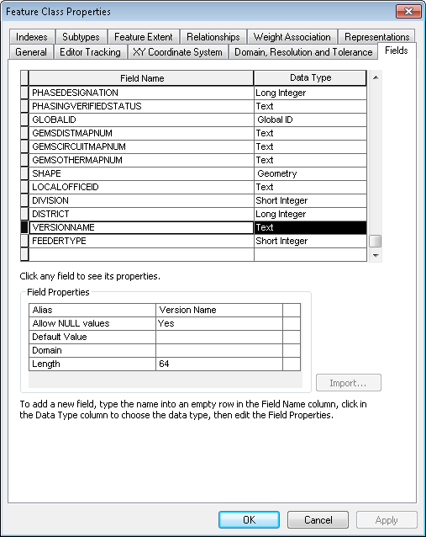

1. Field Name: **FEEDERTYPE**
   1. Type: **Short Integer**
   2. Alias: Feeder Type
   3. Allow Nulls: Yes
   4. Default Value:
   5. Domain: Feeder Types
   6. Precision: 5

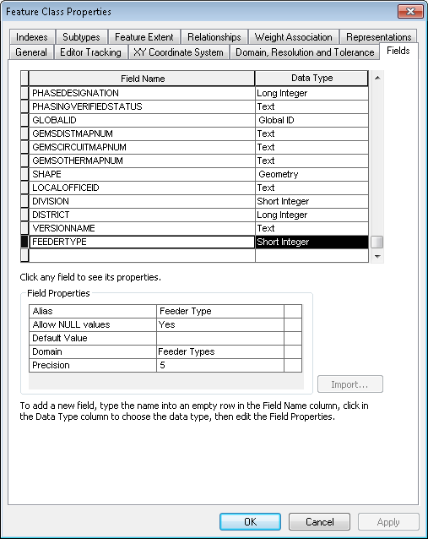

1. Select the “Subtype” tab
2. Highlight the Network Protector subtype
3. Select the FEEDERTYPE field in the bottom half of the dialog and make sure the domain “Feeder Types” is assigned.

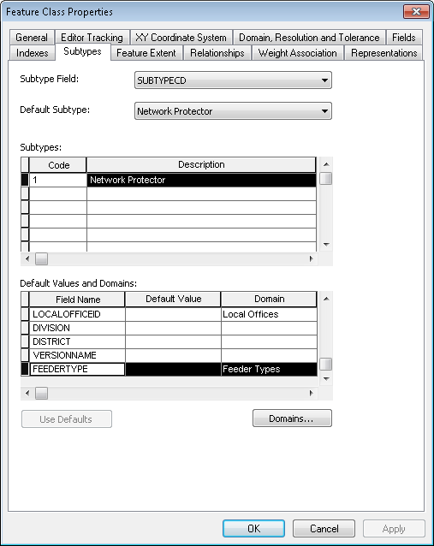

# Part #2 Model Names that must be configured:

1. Open ArcCatalog and connect to the eder maintenance database as the EDGIS user.
2. Right click on the Network Protector feature class and choose the “ArcFM Properties” option.
3. Choose the “ModelNames” tab
4. Assign the below list of Model Names:
   1. PGE_EDSCHEM_CHANGEDETECTION
   2. PGE_FEEDERTYPE
5. Hit Apply to save the model names

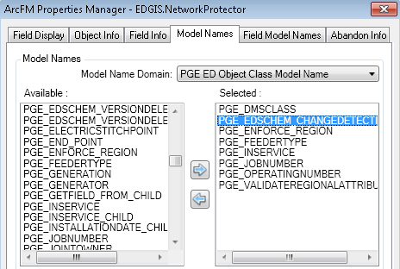

1. Now select the “Field Model Names” tab.
2. Assign the following field model names to the fields below:

Field => Model Name

* 1. **Version Name** => **PGE_VERSIONNAME**

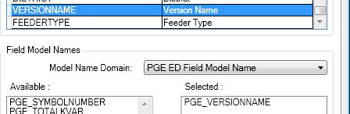

* 1. **Feeder Type** => **PGE_FEEDERTYPE**

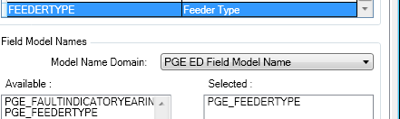

1. Hit ok to apply the field model names.

# Part #3 AUs that must be configured:

1. Open ArcCatalog and connect to the eder maintenance database as the EDGIS user.
2. Right click on the Network Protector feature class and choose the “ArcFM Properties Manager” option.
3. Choose the “Object Info” tab
4. Assign the below list of Auto Updaters

## On Feature Create: choose <multiple…>

* PGE Record Version
* PGE Segment Split
* ArcFM Feeder Cache Maintenance

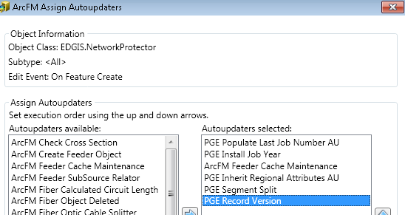

## On Feature Update: choose <multiple…>

* PGE Record Version
* ArcFM Feeder Cache Maintenance

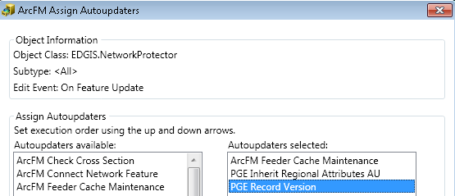

## On Feature Delete:

* ArcFM Feeder Cache Maintenance

Note: The delete is only a single AU and will not have multiple assigned.



# Part #4 Create new Annotation Feature Class for Network Protectors:

1. Open ArcCatalog and connect to the EDER maintenance database as the EDGIS user.
2. Right click on the ElectricDataset
3. Choose the “New Feature Class” option
4. Fill in the below Feature Class information for the Name, Alias, Type and Link and select Next.

Name: NetworkProtectorSchem500Anno

Alias: NetworkProtectorSchem500Anno

Type: ArcFM Annotation Feature

Link: EDGIS.NetworkProtector

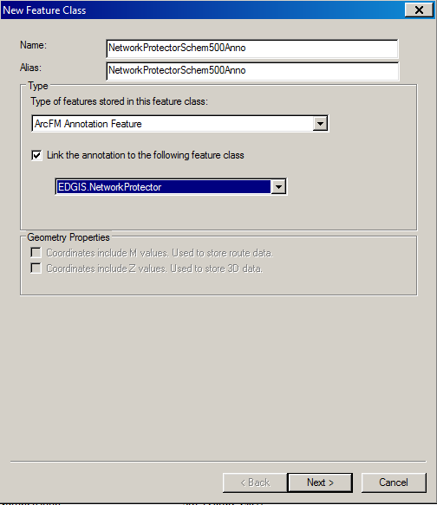

1. Fill in the below Feature Class information for the Reference, Map Units, Editing Behavior, and Label Engine and select Next.

Reference Scale: 1:6,000

Map Units: Feet

Editing Behavior: Check “Create annotation when new features are added”

Label Engine: Standard Label Engine

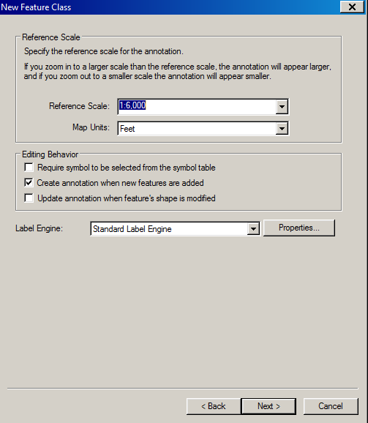

1. Fill in the below Annotation Class and Text Symbol information for the Default Annotation Class and select “Symbol…”

Annotation Class: **Default**

Label Field for Default: **OPERATINGNUMBER**

Font: **Arial**

Size: **3**

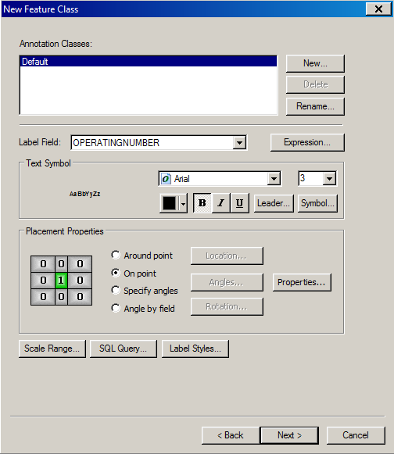

1. Then select “Edit Symbol…”

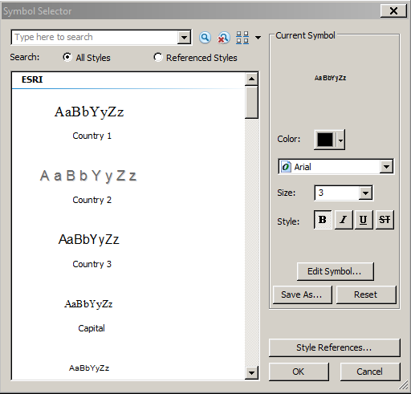

1. Set the Symbol Properties for the below and select OK:  
   Vertical Alignment: Bottom

Horizontal Alignment: Center

X Offset: 25

Y Offset: 10

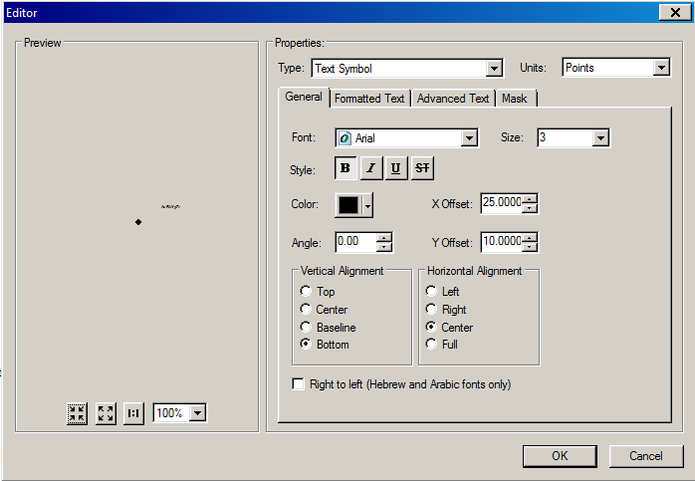

1. Select “On point” for Placement Properties then “Properties…”

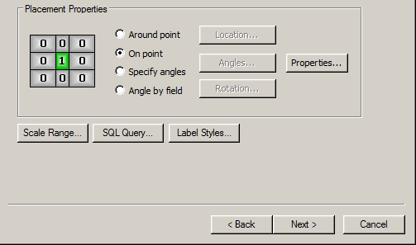

1. Select “Place label on top of the point” and select the “Conflict Detection” tab.

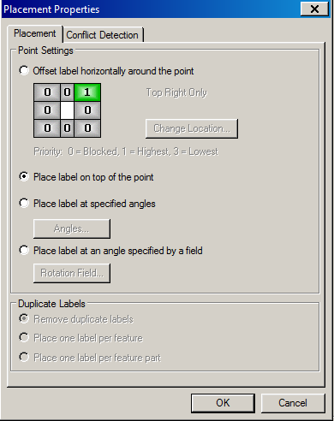

1. Set Label Weight and Feature Weight to “High.” Then check the “Place overlapping labels” option. Once complete, hit OK.

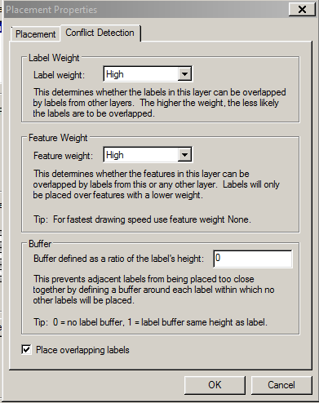

1. Select Next.

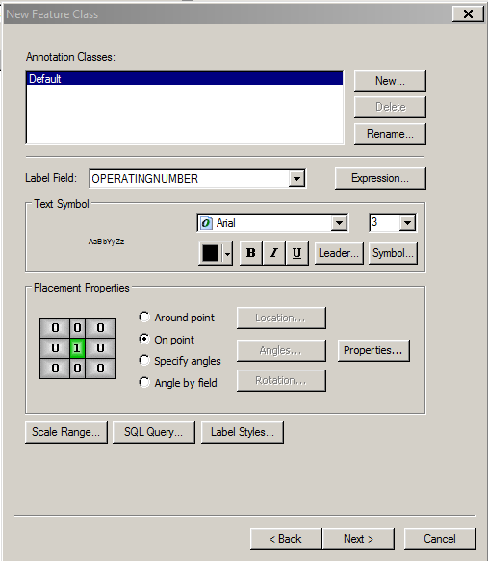

1. Keep Default for Configuration Keyword and select Next.

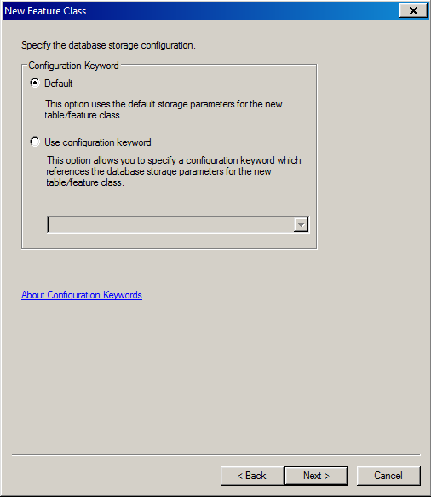

1. Create FEEDERTYPE field on the NetworkProtectorSchem500Anno feature class with the following settings and select Finish.

Name: FEEDERTYPE

Data Type: Short Integer

Alias: Feeder Type

Allow NULL Values: Yes

Domain: Feeder Types

Precision: 5

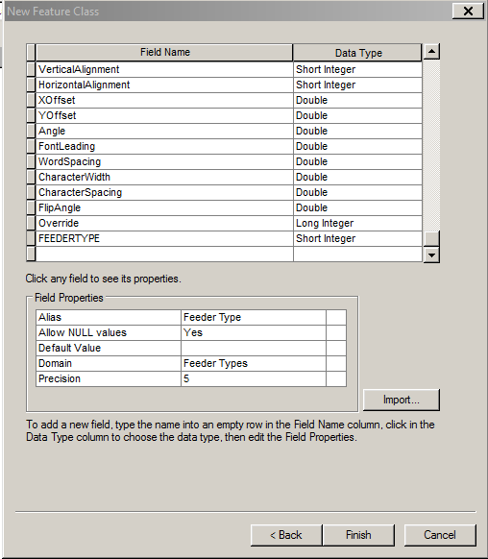

# Part #5 AUs and Model Names for Annotation Feature Class:

1. Open ArcCatalog and connect to the EDER maintenance database as the EDGIS user.
2. Right click on the NetworkProtectorSchem500Anno
3. Choose the “ArcFM Properties Manager” option
4. Select the Model Names Tab
5. Add the Model Name: PGE_FEEDERTYPE

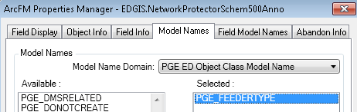

1. Click Apply
2. Select the Field Model Names tab
3. Add the following field => model name combination:
   1. FEEDERTYPE => PGE_FEEDERTYPE

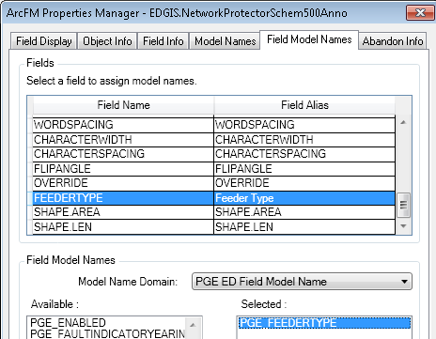

1. Click Apply
2. Click OK

# Part #6 Rename the Relationship for the new Annotation Feature Class:

1. Open ArcCatalog and connect to the EDER maintenance database as the EDGIS user.
2. Right click on the new relationship, will be named something like “EDGIS.Anno_####_####”



Note: If you are unable to find the relationship, look for it by selecting the properties on the annotation class, it will show the name, example below is EDGIS.Anno_14237_20441

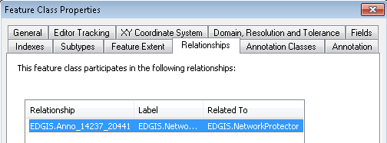

1. Choose the rename option
2. Rename the relationship to “NetworkProtectSchem500AnnoRel”

